Project Development Phase
Model Performance Test

Date | 10 February 2025
Team ID | LTVIP2026TMIDS76616
Project Name | HematoVision – Advanced Blood Cell Classification Using Transfer Learning
Maximum Marks | 10 Marks

Model Performance Testing:
Project team shall fill the following information in model performance testing template.
S.No. | Parameter | Values | Screenshot
 | Metrics | Regression Model:  Not Applicable (Project is Classification Based)  Classification Model:  Classification Model: Confusion Matrix generated for five blood cell classes (Eosinophil, Lymphocyte, Monocyte, Neutrophil, Others). Accuracy Score: 88.94%. Precision, Recall, and F1-score were calculated for each class. | 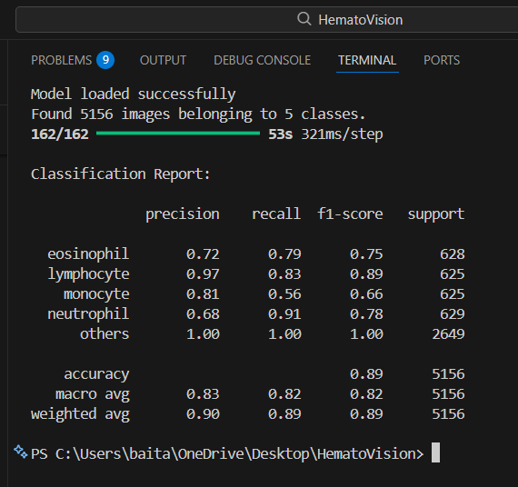  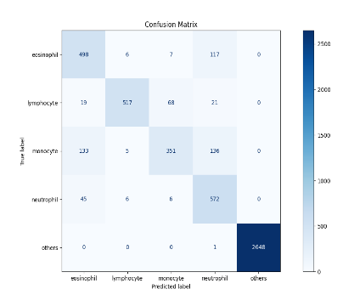
 | Tune the Model | Hyperparameter Tuning: Fine-tuning was performed by unfreezing selected higher layers of the MobileNetV2 base model and reducing the learning rate to 0.0001 to improve generalization.  Validation Method: The model was evaluated using a separate train-validation folder structure to avoid data leakage and ensure reliable performance estimation. | 